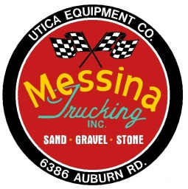
MESSINA TRUCKING INC.
6386 Auburn Road Shelby Twp., MI 48317
586-731-0150 Fax 586-731-7651

Business Credit Application

Business Name______________________________________________

Address__________________________________________________________________________________
(Street) (City) (State) (Zip)

Phone# ___________________________ Fax#___________________________

Officers/Owners_____________________________________________________________________________
(Name) (Title)

Account payable contact_____________________________ Email______________________________________

Fed Tax ID number ____________________________

Tax Exempt ( ) NO ( ) YES, attach exemption certificate
Number of years
Type of Business ___________________________ Year Established_______________ at present location____________

Form of Business ( ) Corporation ( ) Partnership ( ) LLC ( ) Proprietorship

Trade References:

Company________________________________ Phone____________________ Fax________________________

Company________________________________ Phone____________________ Fax________________________

Company________________________________ Phone____________________ Fax________________________

Bank Reference:

Bank Name__________________________________ Address _________________________________

City______________________ State________ Zip_________________

Contact Name __________________________ Phone # _______________________

Page 1
